EXPERIMENT NO: 8

**Name: Riya Jacey Kurian**

**Roll No: 29 Batch: MCA B Date: 03-06-2022**

**AIM:**

**Perform CRUD Operations**

**PROCEDURE:**

**1.CREATE**

* Create Database



* Listing All Databases

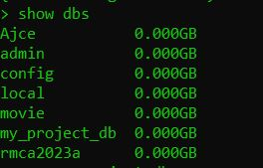

* Creating Collections(Tables)







* Show Collections

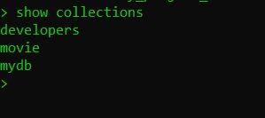

* Inserting Values to Collection





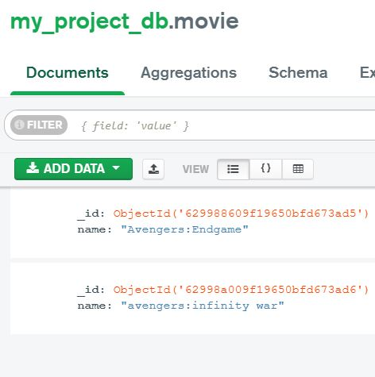

* Insert Multiple values to Collection

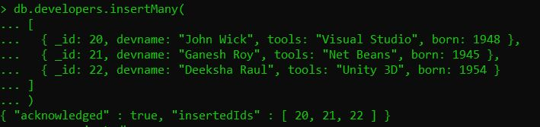

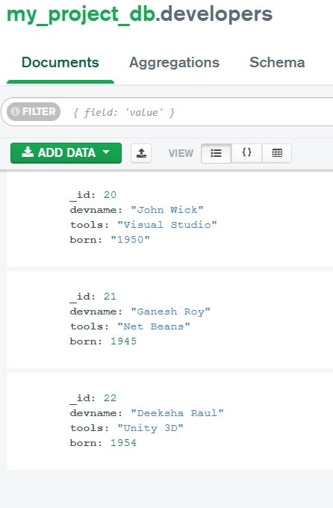

**2. READ**

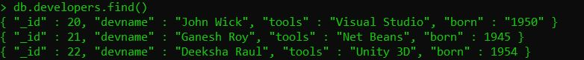

**3. UPDATE**





**4.DELETE**



